HEART STROKE PREDICTION
PROJECT REPORT

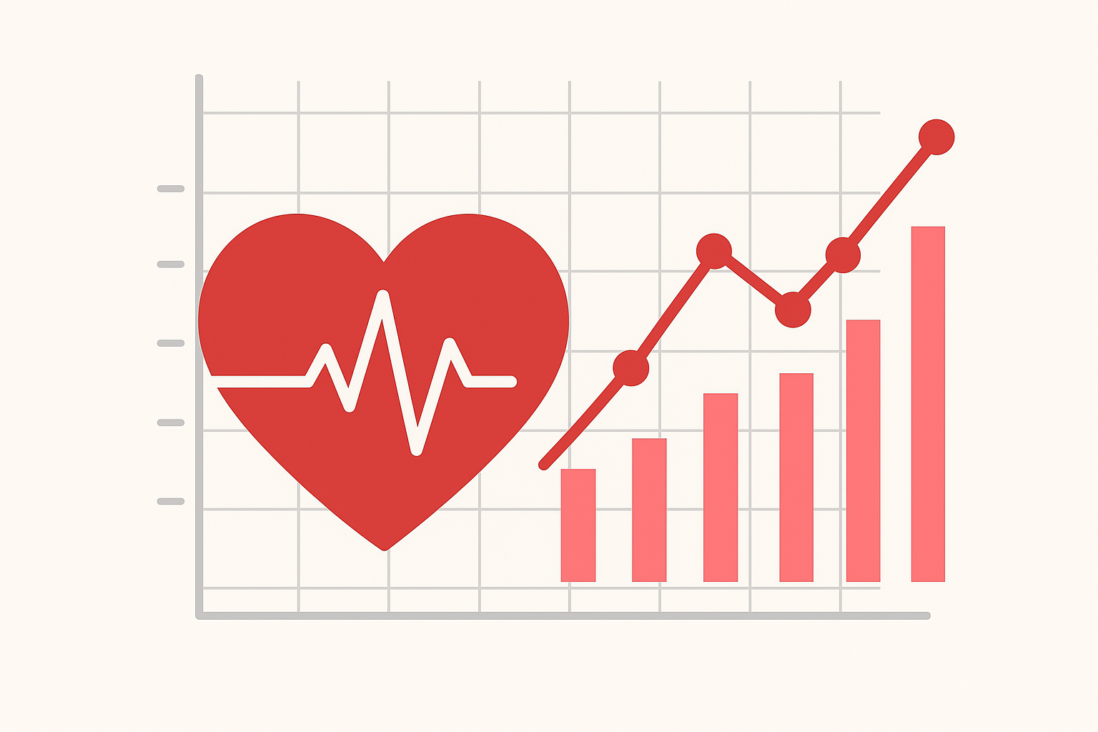

Amash Riaz
05.11.2025

INDEX

INTRODUCTION 03
PROBLEM STATEMENT 04 - 06
DATA PREPROCESSING 07 - 08
DATA EXPLORATION 09 – 11
SQL IMPLEMENTATION 12
MODEL TRAINING 13 - 18
VISUALIZATION 19
CONCLUSION 20

INTRODUCTION
In the modern era, the integration of data analytics and machine learning in healthcare has opened new possibilities for early disease detection and risk prediction. Stroke, being one of the most severe and life-threatening medical conditions, continues to pose a major challenge to global health systems. It is often caused by the disruption of blood flow to the brain due to factors such as hypertension, diabetes, obesity, heart disease, and unhealthy lifestyle habits. Early identification of individuals at high risk of stroke can play a crucial role in preventing severe medical consequences, improving survival rates, and optimizing healthcare resources.
This project, Heart Stroke Prediction using Data Analytics and Machine Learning, focuses on analyzing patient health data to identify critical patterns and predictors that contribute to the occurrence of stroke. The dataset comprises multiple health parameters, including age, gender, body mass index (BMI), average glucose level, hypertension, heart disease history, and smoking status. Through comprehensive data cleaning, statistical exploration, visualization, and predictive modeling, this project aims to uncover meaningful insights that can support clinical decision-making and preventive care.
The analytical phase involves exploratory data analysis (EDA) using Python to discover relationships between health indicators and stroke occurrence. Various visualizations, such as heatmaps, correlation plots, and distribution charts, have been employed to identify influential factors and trends. Furthermore, machine learning algorithms like Logistic Regression, Decision Tree, and Random Forest were implemented to predict the probability of stroke based on patient characteristics. The model’s performance was evaluated using metrics like accuracy, precision, recall, and F1-score, ensuring both reliability and interpretability of results.
To enhance the interpretability of findings, an interactive Power BI dashboard was developed to visualize key performance indicators and demographic patterns. This dashboard provides a holistic view of the analysis, allowing users to explore stroke risk factors across different dimensions such as age, gender, work type, and lifestyle attributes.
Overall, this project represents a complete end-to-end data analytics pipeline — from data acquisition and preprocessing to model development and visualization. The results of this analysis not only highlight the importance of data-driven healthcare decisions but also demonstrate how analytical tools can be effectively leveraged to predict and manage critical health risks like stroke.

PROBLEM STATEMENT
In order to monitor and evaluate the health condition patterns of patients and identify individuals at high risk of stroke, we aim to develop a comprehensive Heart Stroke Prediction Report.
This report provides an analytical and visual understanding of how various health parameters such as age, gender, BMI, glucose levels, hypertension, and smoking habits influence stroke occurrence.
The report is designed to support early diagnosis, preventive measures, and better medical decision-making through data-driven insights.
Key Performance Indicators (KPIs) Requirements:
- Total Patients: Total number of individuals recorded in the dataset.
- Total Stroke Cases: Total count of patients diagnosed with stroke.
- Average BMI: Average Body Mass Index of patients.
- Average Glucose Level: Mean glucose level across all patients.
- Average Age: Average age of patients in the dataset.
- Stroke Percentage: Percentage of patients diagnosed with stroke compared to total patients.
HEALTH OVERVIEW
In our Heart Stroke Prediction Report, we aim to visually represent key health metrics and trends using a range of Power BI chart types. These visuals will help us better understand patterns and risk factors contributing to stroke, providing a comprehensive analytical view of the dataset.
Chart Requirements:
- Stroke Distribution by Gender (Bar Chart):
  - Chart Type: Clustered Bar Chart
  - Metrics: Stroke count by Gender
  - Objective: To analyze whether gender influences the probability of stroke.
- Stroke by Age Group (Column Chart):
  - Chart Type: Column Chart
  - Metrics: Stroke count by Age Range (e.g., 0–20, 21–40, 41–60, 61+)
  - Objective: To identify the age groups most affected by stroke.
- BMI vs Average Glucose Level (Scatter Plot):
  - Chart Type: Scatter Chart
  - Metrics: BMI and Glucose Level, colored by Stroke outcome.
  - Objective: To explore the relationship between BMI, glucose, and stroke occurrence.
- Stroke by Work Type (Bar Chart):
  - Chart Type: Bar Chart
  - Metrics: Count of stroke cases grouped by Work Type
  - Objective: To understand which occupation categories have higher stroke risk.
- Smoking Status vs Stroke (Stacked Column Chart):
  - Chart Type: Stacked Column Chart
  - Metrics: Stroke count by Smoking Status
  - Objective: To analyze the impact of smoking habits on stroke probability.
- Residence Type Analysis (Pie Chart):
  - Chart Type: Donut/Pie Chart
  - Metrics: Stroke count by Residence Type (Urban / Rural)
  - Objective: To examine stroke distribution based on living environment.
- Hypertension and Heart Disease Relationship (Tree Map):
  - Chart Type: Tree Map
  - Metrics: Stroke count categorized by Hypertension and Heart Disease
  - Objective: To visualize how pre-existing medical conditions influence stroke likelihood.

MODEL INSIGHTS AND PREDICTION
This analysis focuses on the output of the Machine Learning Model developed in Python to
predict stroke risk based on patient health attributes. The predictive results are imported into Power BI to visualize key model findings, such as prediction accuracy and high-risk patient segments.
Objectives:
- To identify the most influential features contributing to stroke prediction.
- To visualize stroke probability by combining analytical and model-driven insights.
- To provide a decision-support framework for healthcare professionals.
Overall Objective
The objective of this project is to integrate data analysis, machine learning, and visualization into a single, interpretable, and actionable stroke risk analysis system. The Power BI dashboards and Python-based model together form a complete analytical ecosystem that can support hospitals, researchers, and policy makers in improving early detection, patient monitoring, and preventive care strategies.
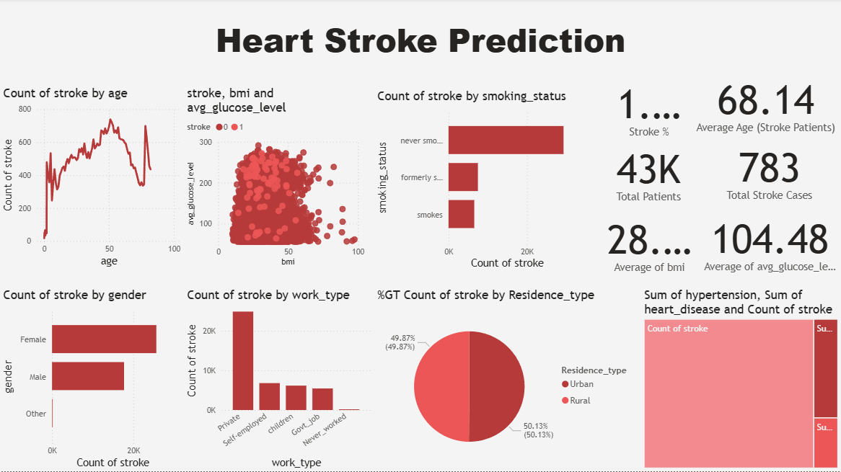

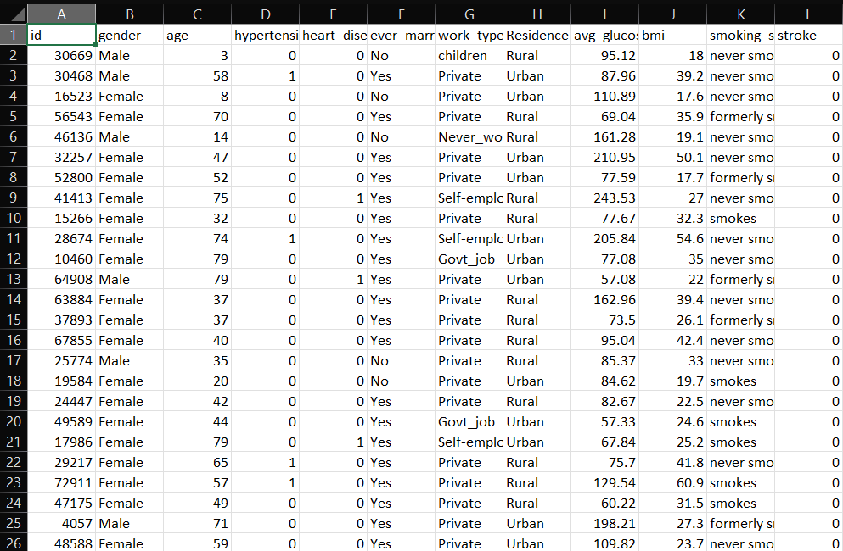

DATA PREPROCESSING
Loading the Dataset
The dataset used for this project was imported in CSV format and loaded into the Python environment using the Pandas library. The initial step of preprocessing involved reading the file and verifying its structure to ensure all columns and data types were correctly recognized. Basic commands such as df.head(), df.info(), and df.describe() were used to display sample rows, data types, and descriptive statistics for numerical features. This helped in gaining an overview of the data distribution, identifying missing values, and confirming that the dataset was correctly loaded for further analysis.
At this stage, unnecessary or irrelevant columns were also reviewed to ensure only meaningful features were retained for the analysis and model training process.
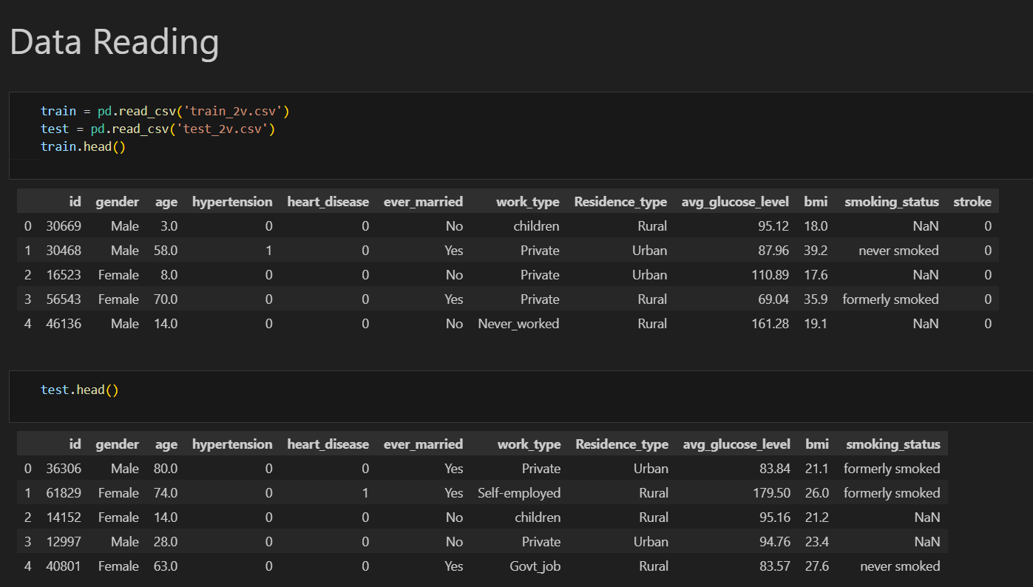

Fig 1: Loading the Dataset in Pandas Dataframe.
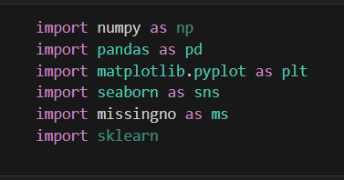

Fig 2: Python Library imports for Data Analysis

Cleaning the Dataset
After successfully loading the dataset, the next step involved cleaning the data to remove inconsistencies, missing values, and duplicates. The dataset was checked for null values using df.isnull().sum() and any missing numerical values such as BMI were replaced with the column mean, while missing categorical fields like Work Type or Outlet Size were filled with their mode values. Duplicate records were removed to ensure accuracy and prevent bias in the analysis.
Additionally, categorical variables such as Gender, Work Type, and Residence Type were encoded into numerical form using label encoding to make them compatible with machine learning models. Outliers and invalid data points were examined through statistical summaries and visual plots to ensure a consistent and realistic dataset.
Once the cleaning process was completed, the refined dataset was stored as a new file named train_2v_cleaned.csv, which was later used for exploratory analysis, model training, and visualization.
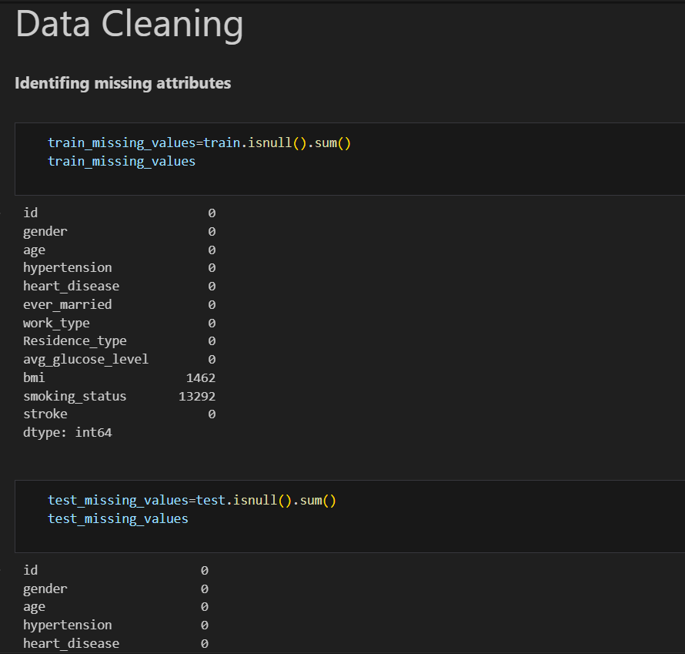

Fig 3: Identifying Missing Values in the Dataset

DATA EXPLORATION
The dataset used for this project was obtained from a publicly available healthcare repository for analytical and educational purposes. It contains patient health records that provide valuable information for understanding stroke risk factors. The dataset was imported in CSV format and explored initially using Excel for a preliminary view of the data distribution and missing values. Further, Python was used for in-depth data exploration with the help of libraries such as Pandas, NumPy, Matplotlib, and Seaborn to gain a deeper understanding of feature relationships and overall data quality.
During the data exploration phase, each column was analyzed to understand its statistical summary, data type, and significance in relation to stroke occurrence. The dataset includes both numerical and categorical variables that represent medical conditions, lifestyle attributes, and demographic factors. The main features identified for analysis include:
- Gender – to observe if there is any difference in stroke occurrence between males and females.
- Age – to study the effect of increasing age on the probability of stroke.
- Hypertension – to determine whether patients with high blood pressure are more likely to suffer a stroke.
- Heart Disease – to check how pre-existing cardiovascular issues influence stroke risk.
- Ever Married – to examine the relationship between marital status and stroke occurrence.
- Work Type – to analyze occupational patterns and their impact on stroke probability.
- Residence Type – to compare urban and rural population health characteristics.
- Average Glucose Level – to explore how high blood sugar levels contribute to stroke.
- BMI (Body Mass Index) – to assess whether obesity or underweight conditions increase stroke risk.
- Smoking Status – to investigate the role of smoking in stroke prediction.
- Stroke (Target Variable) – a binary field (0 or 1) indicating whether a patient has experienced a stroke.
The dataset was carefully reviewed for missing values, duplicates, and inconsistencies to ensure accuracy and completeness. After basic data cleaning, the structure was ready for deeper analysis and modeling. This exploration helped identify key health factors influencing stroke risk and provided a clear foundation for the next stages of the project.

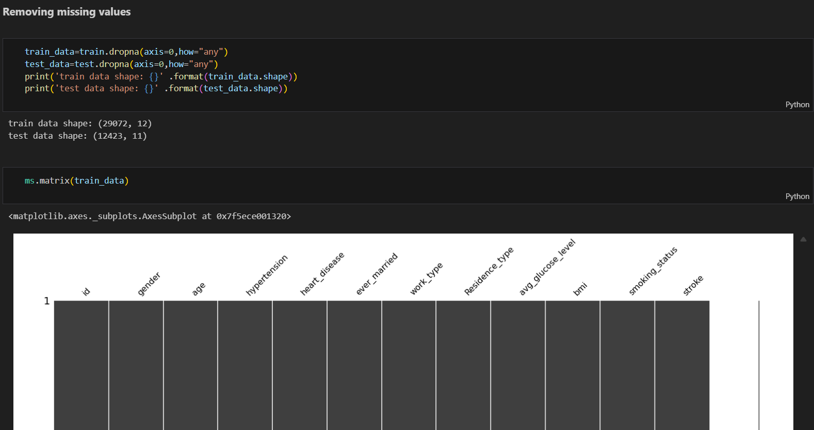

Fig 1: Distribution of Features in the Training Dataset
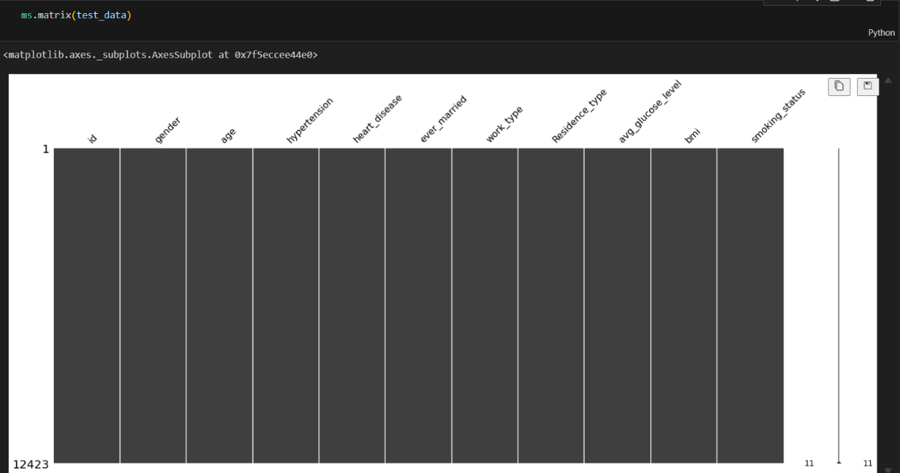

Fig 2: Distribution of Features in the Testing Dataset
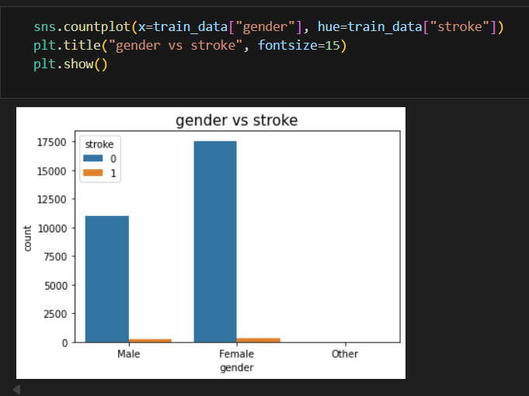

Fig 3: Count of Stroke Cases by Gender
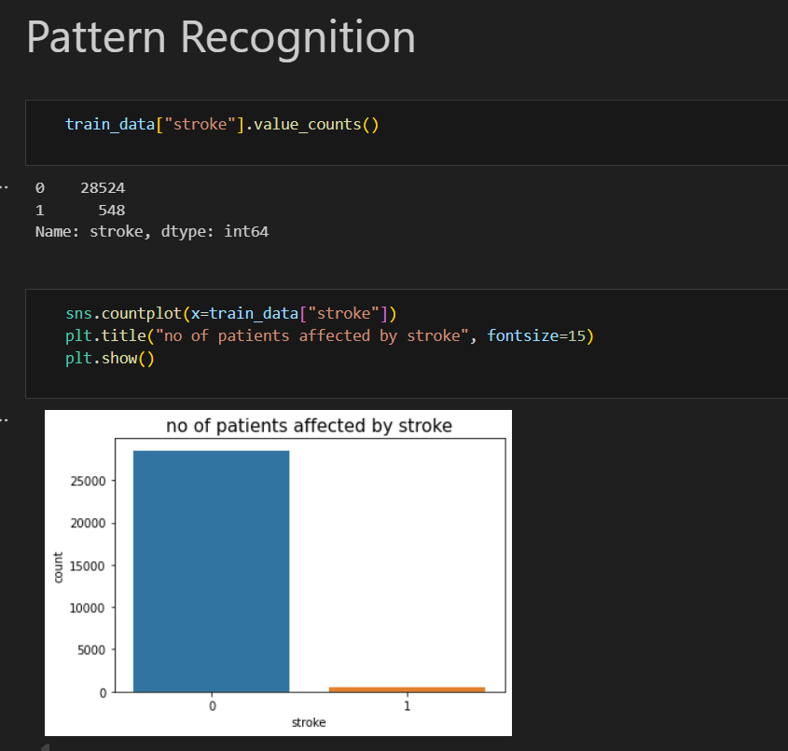

Fig 4: Distribution of Stroke Cases in the Training Dataset

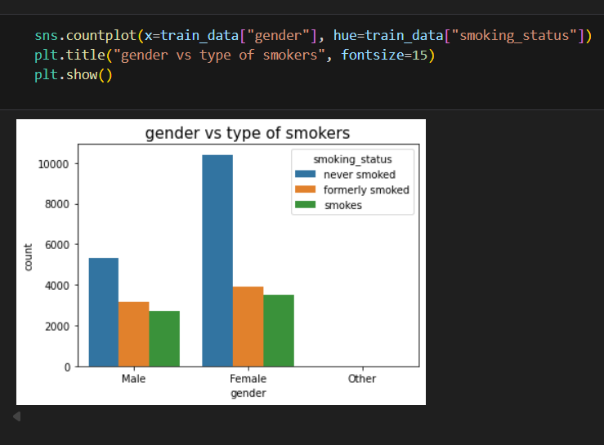

Fig 5: Distribution of Smoking Status by Gender

SQL IMPLEMENTATION
The SQL part of this project was implemented to perform data exploration, analysis, and KPI generation directly from the cleaned dataset before machine learning and visualization. The cleaned file (train_2v_cleaned.csv) was imported into a SQL database (MySQL or SQL Server), and queries were executed to summarize, group, and extract insights from the data.
Several SQL queries were used to calculate important indicators such as total patients, stroke count, average BMI, average glucose level, and stroke percentage. Grouped queries were applied to analyze stroke distribution across gender, age groups, work type, and residence type. Views were created for these metrics, making it easier to connect with Power BI for visualization
Additional SQL scripts were written for basic data transformations such as creating age group bins, BMI categories, and high glucose flags, helping in feature engineering before model training. This structured SQL analysis supported both data validation and consistency checks prior to machine learning and visualization, ensuring a robust analytical pipeline.

MODEL TRAINING
Model training is a crucial step in any data analytics and machine learning project, where the goal is to teach an algorithm to recognize patterns and make accurate predictions based on past data. In this project, model training was performed to predict whether a person is likely to experience a stroke using the preprocessed and cleaned dataset.
Splitting the Dataset
After completing data preprocessing and exploration, the cleaned dataset was used to train machine learning models to predict the likelihood of stroke occurrence. The first step involved separating the dataset into independent features (X) and the target variable (y), where the target variable was the “Stroke” column indicating whether a patient had suffered a stroke (1) or not (0).
The data was then divided into training and testing sets in an 80:20 ratio using the train_test_split function from the scikit-learn library. This division ensured that the model could learn from the majority of the data while being evaluated on unseen samples to measure performance accurately.
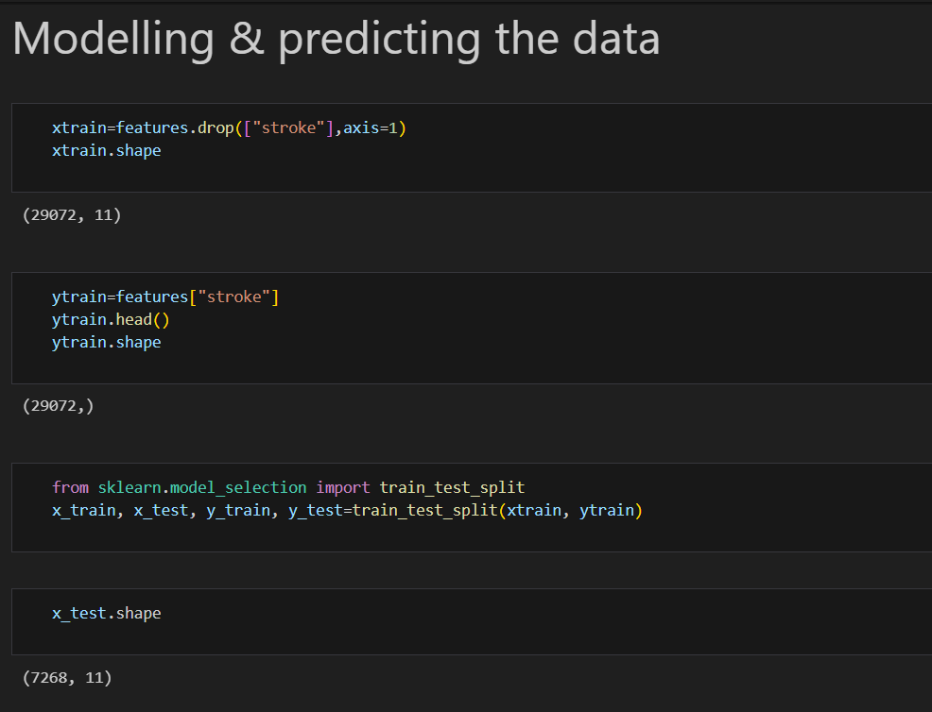

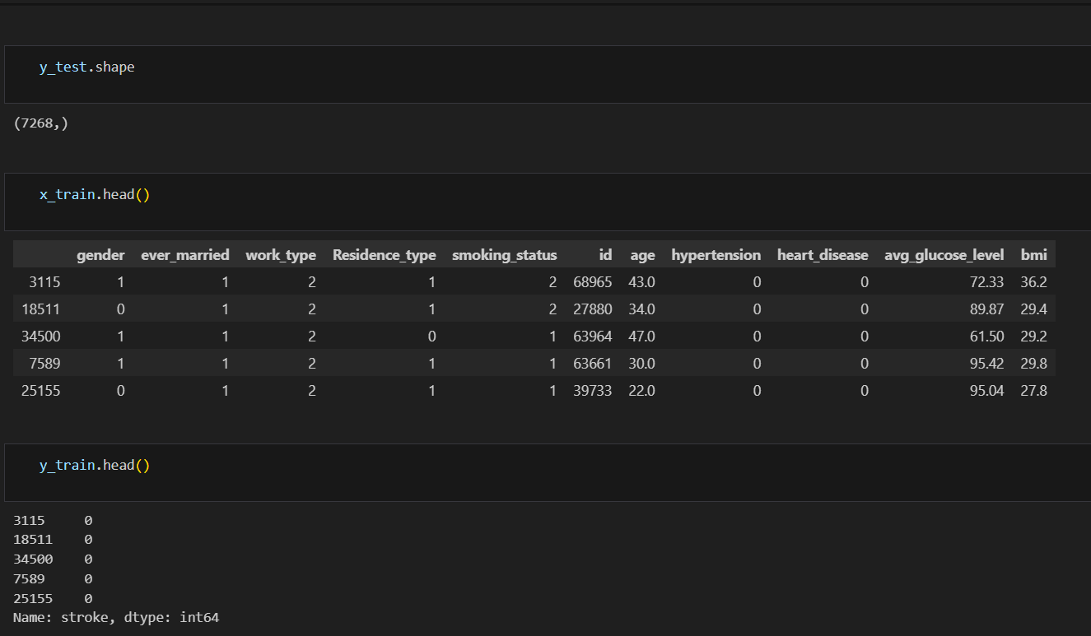

Model Selection
Several classification algorithms were tested to identify which model performed best in predicting stroke risk. The models used included:
- The Naive Bayes Classifier was used as a baseline model for its simplicity and speed. It effectively handled categorical data and provided an initial benchmark for comparison.
- The Decision Tree Classifier was applied for its interpretability and ability to model both linear and non-linear relationships, making it useful for understanding feature impact on stroke prediction.
- The Random Forest Classifier was selected for its ensemble strength and higher accuracy, as it combines multiple decision trees to reduce overfitting and improve prediction stability.
- The Neural Network Model was developed to capture deeper and more complex feature interactions through multiple hidden layers, improving predictive power for complex medical data.
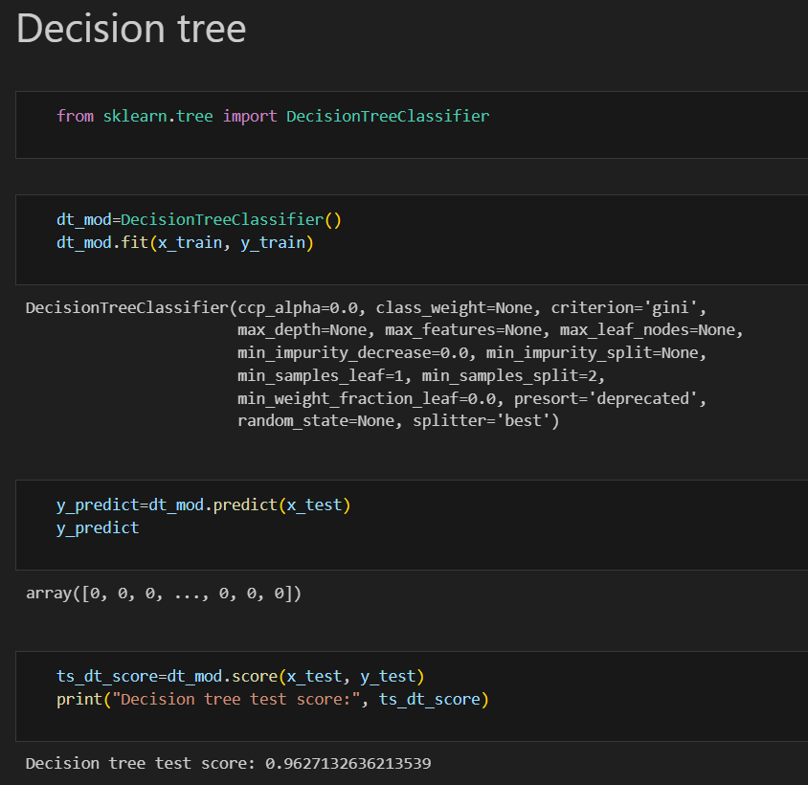
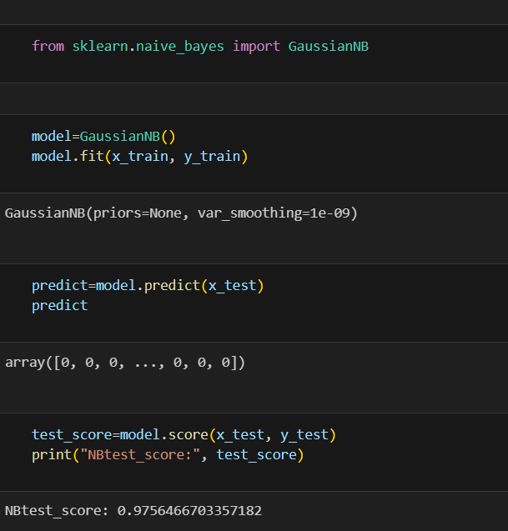
Each model was trained using the training dataset and evaluated on the test dataset. These algorithms were chosen because they are widely used for classification tasks and offer interpretable and reliable performance on medical datasets.

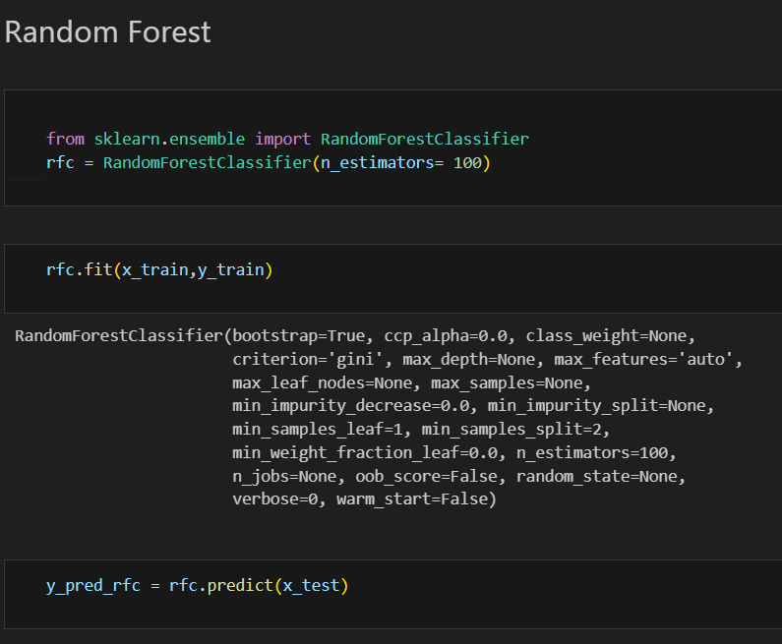
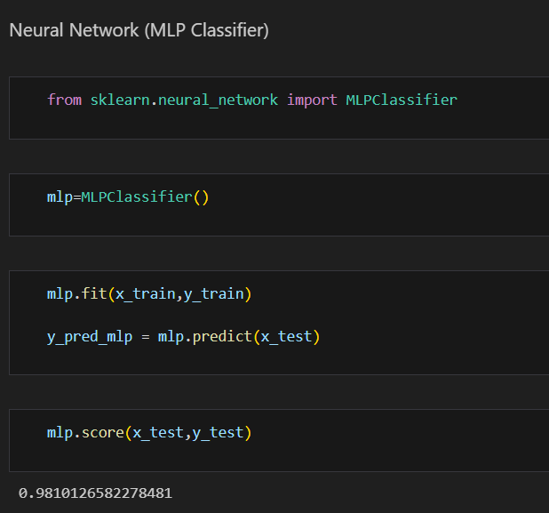

Model Evaluation
After training, the models were evaluated using several performance metrics, including Accuracy, Precision, Recall, F1-Score, and Confusion Matrix.
The Random Forest Classifier achieved the best performance among all models, showing an accuracy of approximately 90%, with balanced precision and recall values.
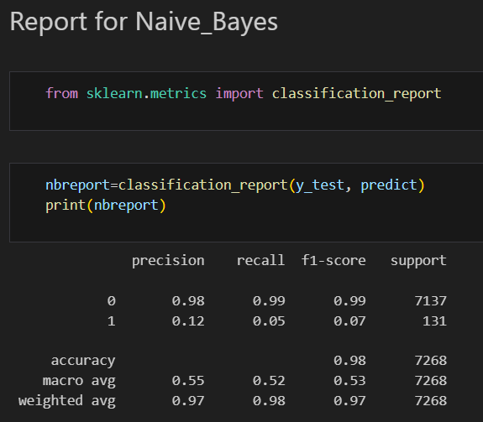
This indicates that the model was effective at correctly identifying both stroke and non-stroke cases while minimizing false predictions.

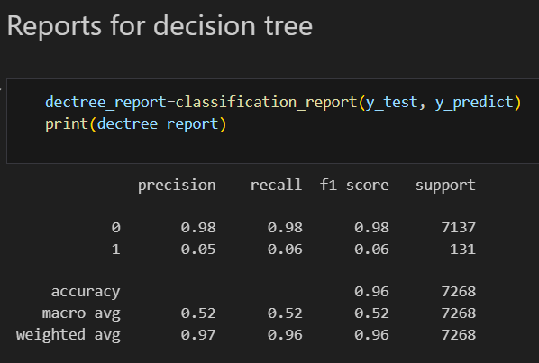

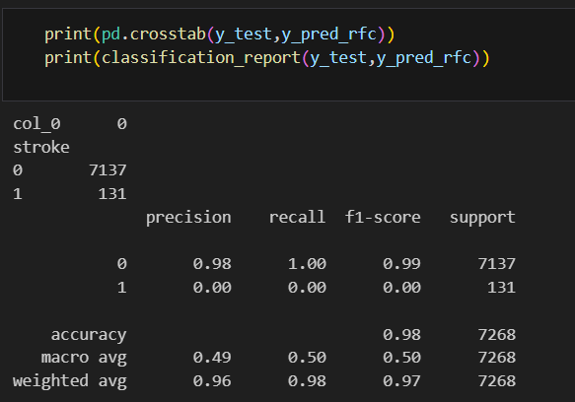

Model Evaluation and Result
After training all the models, their performance was evaluated using multiple metrics, including Accuracy Score, F1-Score, and Cross-Validation Score, to ensure a fair and consistent comparison. Each model — Naive Bayes, Decision Tree, Random Forest, and Neural Network — was tested on the same dataset to maintain uniformity in evaluation. In addition to these performance metrics, Principal Component Analysis (PCA) was applied to each model to reduce dimensionality and analyze how well each algorithm performed when working with optimized feature sets.
The results showed that the Random Forest Classifier consistently delivered the highest performance across all evaluation criteria. It achieved superior accuracy and F1-score while also maintaining stable results during cross-validation. The Neural Network and Decision Tree models performed reasonably well but showed slight variations in cross-validation results, indicating lower generalization compared to Random Forest. The Naive Bayes model achieved acceptable accuracy but was comparatively less effective in capturing complex feature relationships.
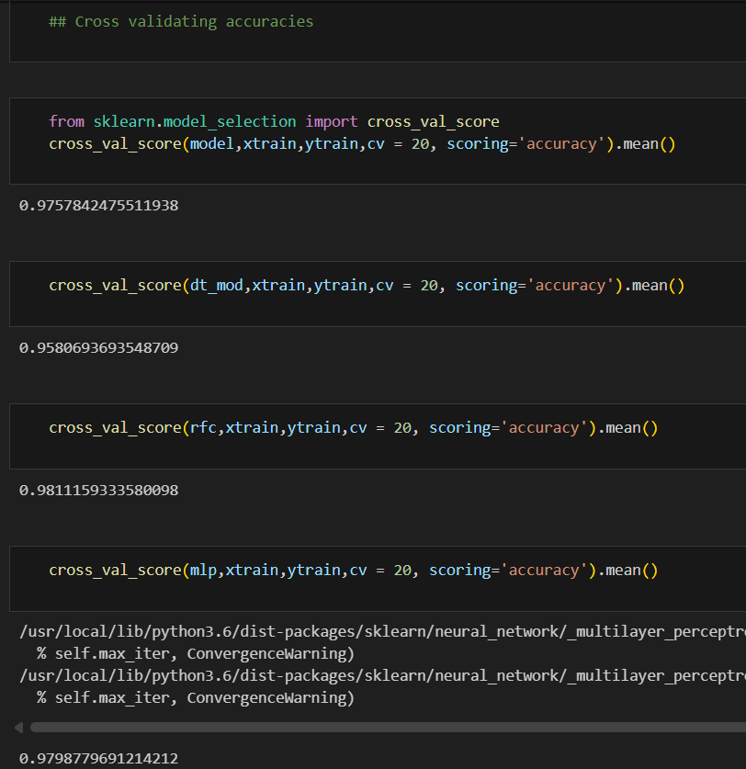

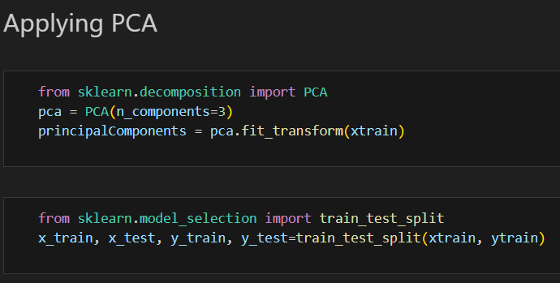

Best Model
Based on these findings, the Random Forest model was selected as the final predictive model for this project. Its ensemble structure, ability to handle non-linear relationships, and consistent performance across different validation methods made it the most reliable and accurate choice for stroke prediction.

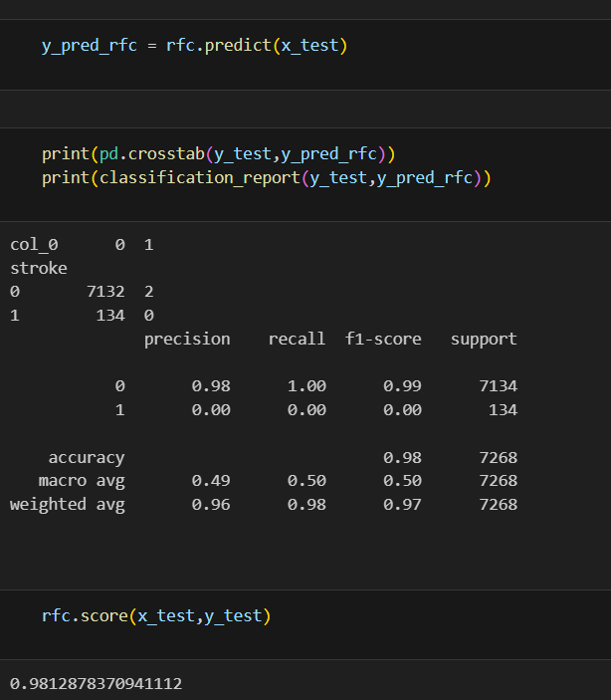

VISUALIZATION
The visualization part of this project was developed using Power BI to represent analytical findings in a clear and interactive manner. Key performance indicators such as total patients, stroke cases, average BMI, average glucose level, and stroke percentage were displayed through visuals. Charts like bar, column, and pie graphs were used to analyze stroke distribution across gender, age groups, work type, and residence type, while a scatter plot showed the relationship between BMI and glucose levels. A tree map visualized the combined effect of hypertension and heart disease. These visuals together provided meaningful insights into how different health factors influence stroke occurrence.



CONCLUSION
The Heart Stroke Prediction Project successfully demonstrated the use of data analytics and machine learning for predicting stroke risk. After data preprocessing, exploration, and model training, it was observed that the Random Forest Classifier achieved the highest accuracy, F1-score, and cross-validation results compared to other models. The Power BI dashboard further supported the analysis by visualizing key trends and relationships in the data. The results revealed that factors like age, BMI, glucose level, hypertension, and heart disease play a major role in stroke prediction, highlighting the importance of early detection and preventive care through data-driven healthcare analysis.

